# SCENARIO #1

Write a maven java project using Spring MVC/Spring Boot and Spring Data or Hibernate as persistence layer to address the following requirement:

* Create RESTFul services to perform the CRUD operations (SAVE (INSERT/UPDATE), DELETE, GET) on portfolio information
  + Project ID
  + Project Details
    - Name
    - Description
    - Summary
  + Date Requested
  + Date Required
  + Key Contacts (*)
    - First Name
    - Last Name
    - Phone
    - Email
    - Role
    - Team / Department
  + Estimates
    - Values 1 to 21 (1 being the lowest estimate – Fibonacci Series)
  + Project Type
    - Docs Management
    - Securities & Collateral
  + Is Critical
    - Boolean field to identify if the project is critical to the bank

**Implicit Requirements:**

* Ensure to test the application for quality
* Code coverage to be minimum of 80%

Portfolio REST API :

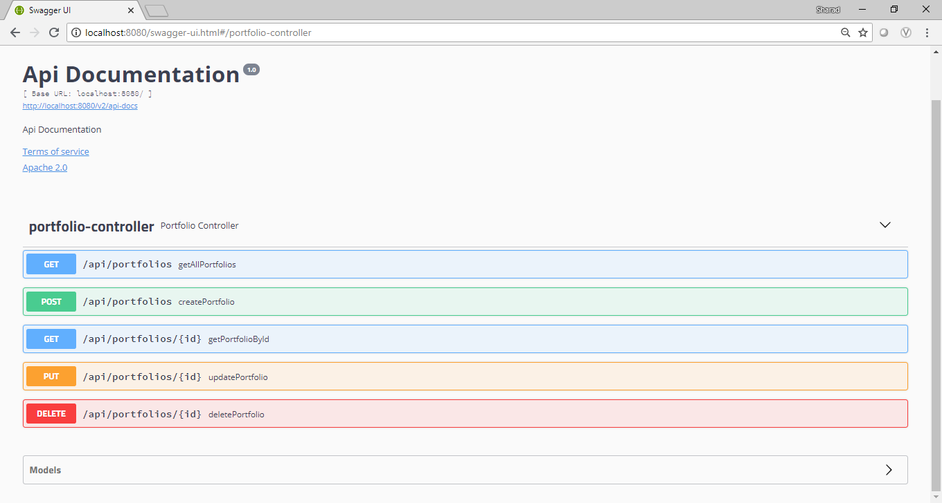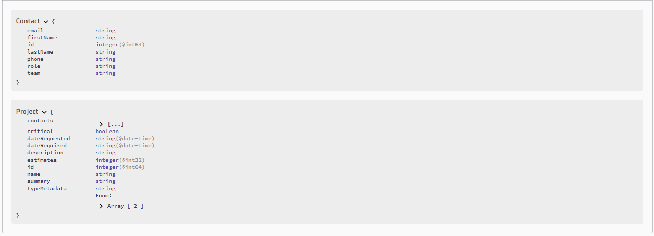

1. Post Portfolio:

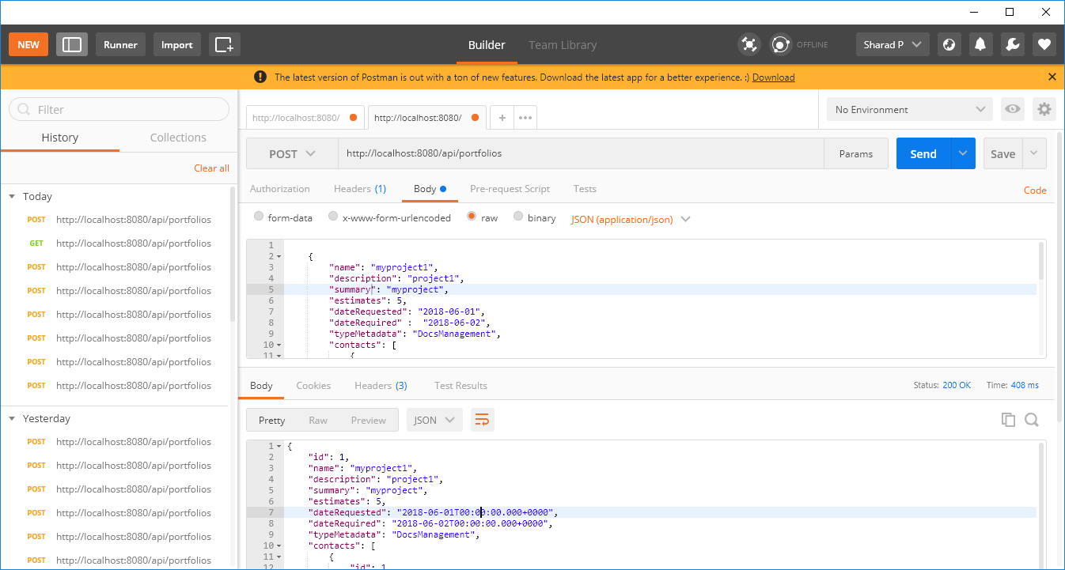

Request1:

|  |
| --- |
| {  "name": "myproject1",  "description": "project1",  "summary": "myproject",  "estimates": 5,  "dateRequested": "2018-06-01",  "dateRequired" : "2018-06-02",  "typeMetadata": "DocsManagement",  "contacts": [  {  "firstName": "abc",  "lastName": "xyz",  "phone": "123",  "email": "abc@xyz.com",  "role": "developer",  "team": "team1"  },  {  "firstName": "john",  "lastName": "D",  "phone": "3456",  "email": "john@company.com",  "role": "analyst",  "team": "paymentsteam"  }  ],  "critical": true  } |

Response 1:

|  |
| --- |
| {  "id": 1,  "name": "myproject1",  "description": "project1",  "summary": "myproject",  "estimates": 5,  "dateRequested": "2018-06-01T00:00:00.000+0000",  "dateRequired": "2018-06-02T00:00:00.000+0000",  "typeMetadata": "DocsManagement",  "contacts": [  {  "id": 1,  "firstName": "abc",  "lastName": "xyz",  "phone": "123",  "email": "abc@xyz.com",  "role": "developer",  "team": "team1"  },  {  "id": 2,  "firstName": "john",  "lastName": "D",  "phone": "3456",  "email": "john@company.com",  "role": "analyst",  "team": "paymentsteam"  }  ],  "critical": true  } |

Database (Mysql) Screenshot:

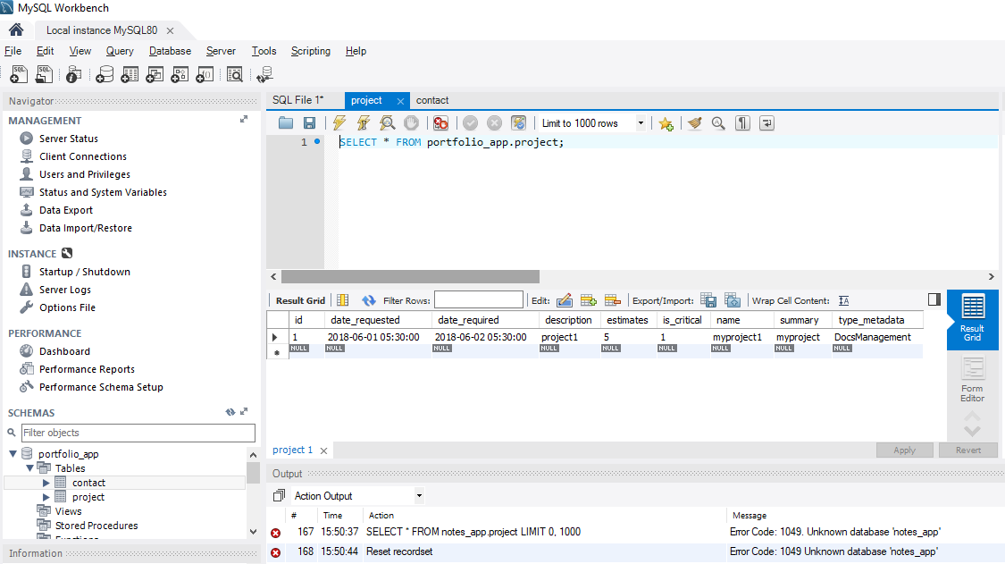

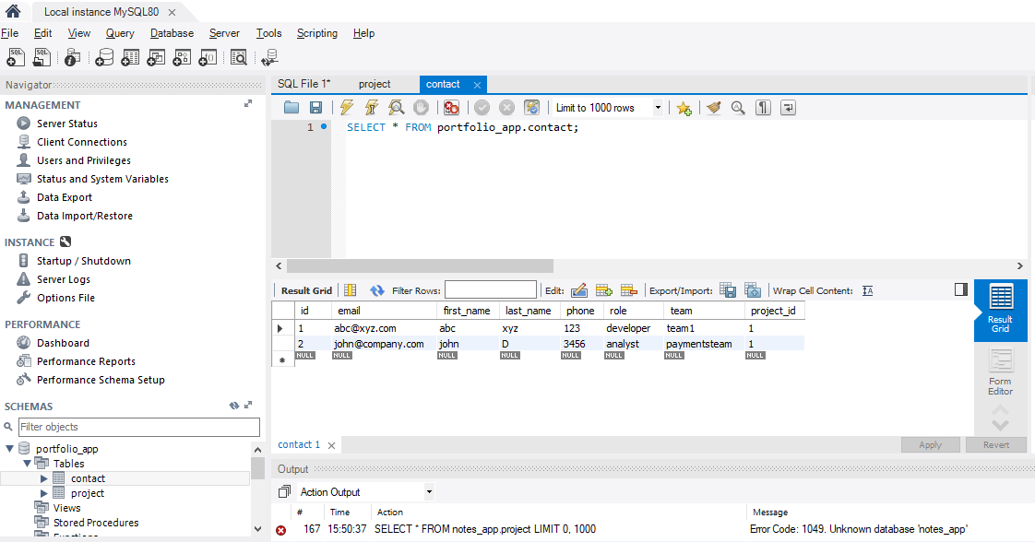

1. GETAllPortfolios:

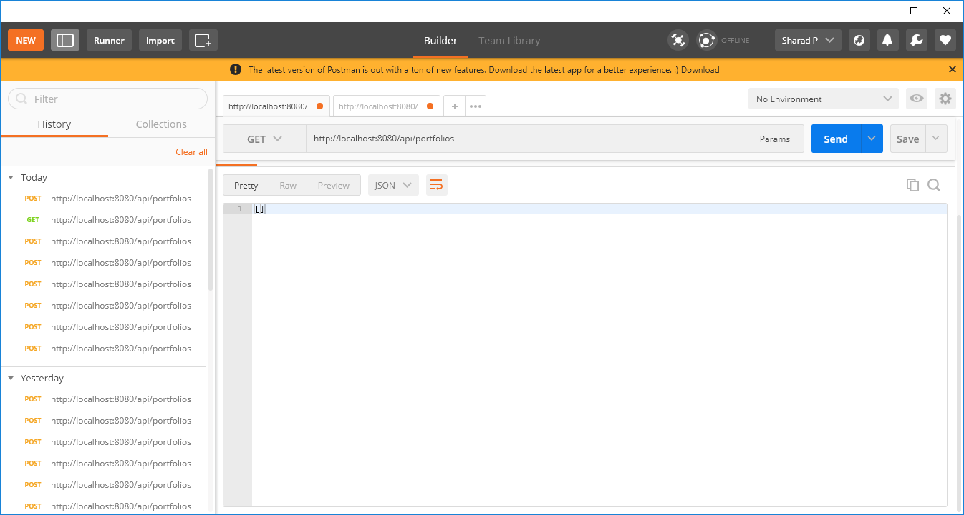

Response:

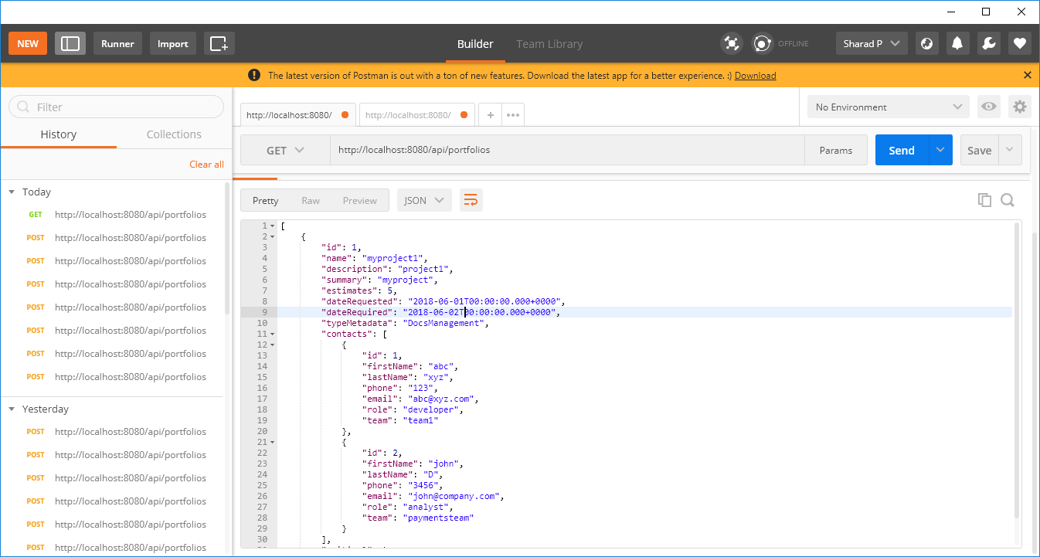

Response:

|  |
| --- |
| [  {  "id": 1,  "name": "myproject1",  "description": "project1",  "summary": "myproject",  "estimates": 5,  "dateRequested": "2018-06-01T00:00:00.000+0000",  "dateRequired": "2018-06-02T00:00:00.000+0000",  "typeMetadata": "DocsManagement",  "contacts": [  {  "id": 1,  "firstName": "abc",  "lastName": "xyz",  "phone": "123",  "email": "abc@xyz.com",  "role": "developer",  "team": "team1"  },  {  "id": 2,  "firstName": "john",  "lastName": "D",  "phone": "3456",  "email": "john@company.com",  "role": "analyst",  "team": "paymentsteam"  }  ],  "critical": true  }  ] |

1. GETPortfolioById

Request:

<http://localhost:8080/api/portfolios/1>

Response:

|  |
| --- |
| {  "id": 1,  "name": "myproject1",  "description": "project1",  "summary": "myproject",  "estimates": 5,  "dateRequested": "2018-06-01T00:00:00.000+0000",  "dateRequired": "2018-06-02T00:00:00.000+0000",  "typeMetadata": "DocsManagement",  "contacts": [  {  "id": 1,  "firstName": "abc",  "lastName": "xyz",  "phone": "123",  "email": "abc@xyz.com",  "role": "developer",  "team": "team1"  },  {  "id": 2,  "firstName": "john",  "lastName": "D",  "phone": "3456",  "email": "john@company.com",  "role": "analyst",  "team": "paymentsteam"  }  ],  "critical": true  } |

1. PUT (update Portfolio)

Request:

|  |
| --- |
| {  "id": 2,  "name": "myproject40",  "description": "project2",  "summary": "myproject",  "estimates": 8,  "dateRequested": "2018-07-01T00:00:00.000+0000",  "dateRequired": "2018-08-02T00:00:00.000+0000",  "typeMetadata": "DocsManagement",  "contacts": [  {  "id": 3,  "firstName": "Ryan",  "lastName": "Bayes",  "phone": "45699834 ",  "email": "ryan@mycompany.com",  "role": "developer",  "team": "teamProduct"  },  {  "id": 4,  "firstName": "john",  "lastName": "D",  "phone": "3456",  "email": "john@company.com",  "role": "analyst",  "team": "paymentsteam"  }  ],  "critical": true  } |

Database before update:

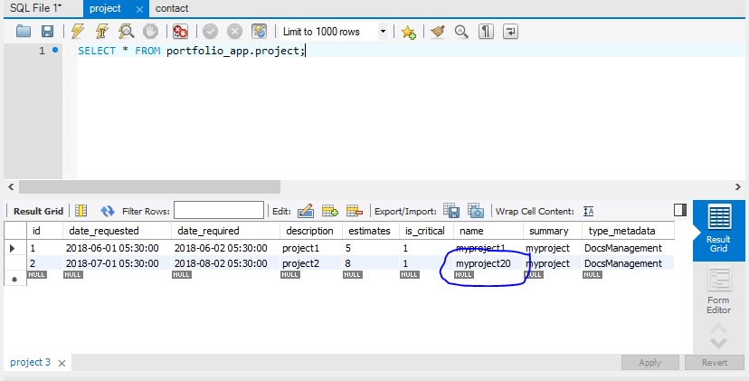

Response:

|  |
| --- |
| {  "id": 2,  "name": "myproject40",  "description": "project2",  "summary": "myproject",  "estimates": 8,  "dateRequested": "2018-07-01T00:00:00.000+0000",  "dateRequired": "2018-08-02T00:00:00.000+0000",  "typeMetadata": "DocsManagement",  "contacts": [  {  "id": 3,  "firstName": "Ryan",  "lastName": "Bayes",  "phone": "45699834 ",  "email": "ryan@mycompany.com",  "role": "developer",  "team": "teamProduct"  },  {  "id": 4,  "firstName": "john",  "lastName": "D",  "phone": "3456",  "email": "john@company.com",  "role": "analyst",  "team": "paymentsteam"  }  ],  "critical": true} |

Database after update:

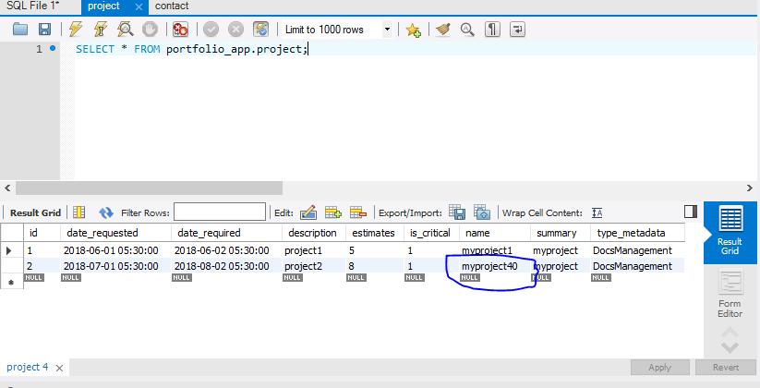

1. Delete Portfolio

Database record before delete:

Project:

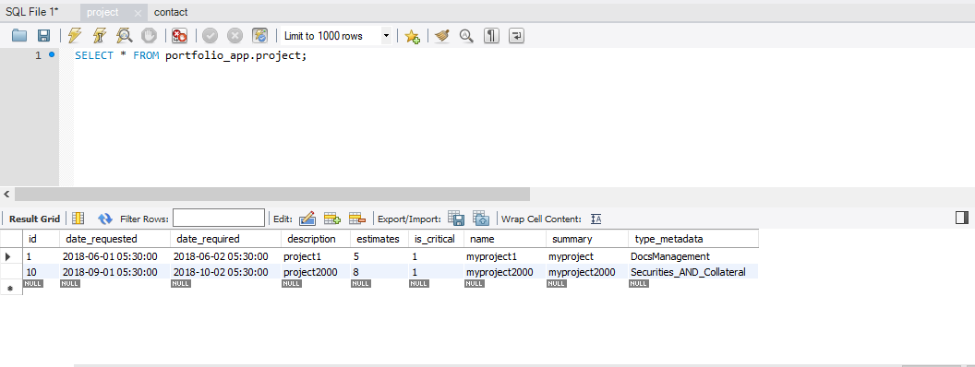

Contact:

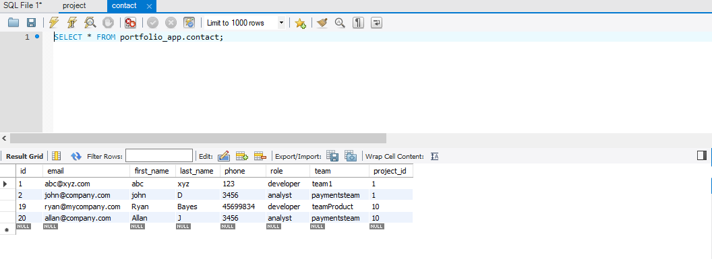

Request: 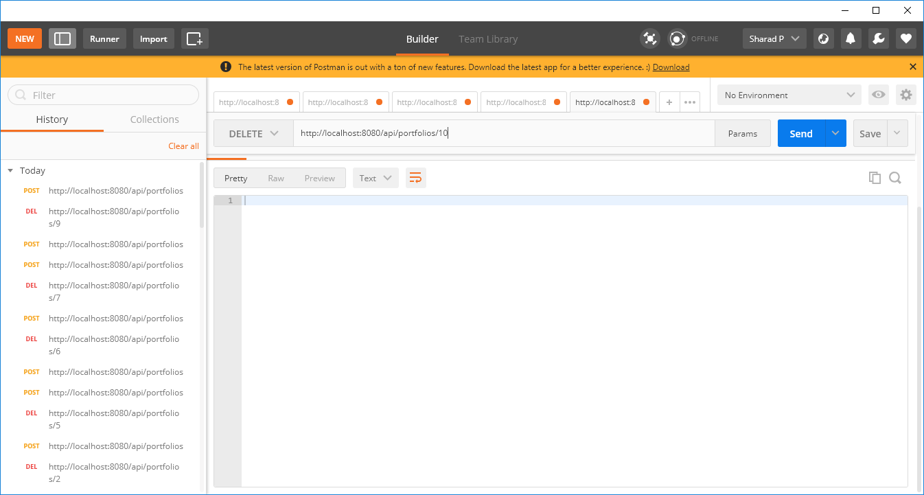

Database After Delete:

Project:

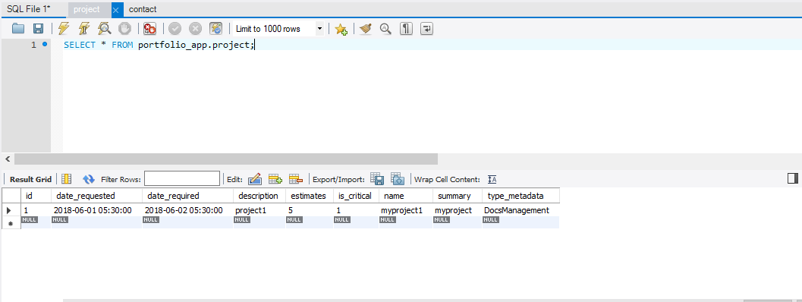

Contact:

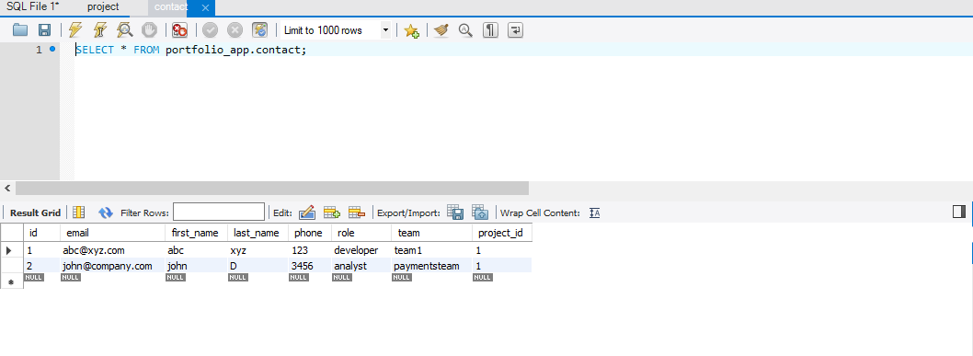

Error Scenarios:

1. Estimates (Fibonacci values 1 to 21) :

Request:

|  |
| --- |
| {  "name": "myproject1",  "description": "project1",  "summary": "myproject",  **"estimates": 0,**  "dateRequested": "2018-06-01",  "dateRequired" : "2018-06-02",  "typeMetadata": "DocsManagement",  "contacts": [  {  "firstName": "abc",  "lastName": "xyz",  "phone": "123",  "email": "abc@xyz.com",  "role": "developer",  "team": "team1"  },  {  "firstName": "john",  "lastName": "D",  "phone": "3456",  "email": "john@company.com",  "role": "analyst",  "team": "paymentsteam"  }  ],  "critical": true  } |

Response:

|  |
| --- |
| {  "timestamp": "2018-09-21T10:25:13.239+0000",  "status": 500,  "error": "Internal Server Error",  "message": "Estimates value is invalid",  "path": "/api/portfolios"  } |

1. ResourceNotFound

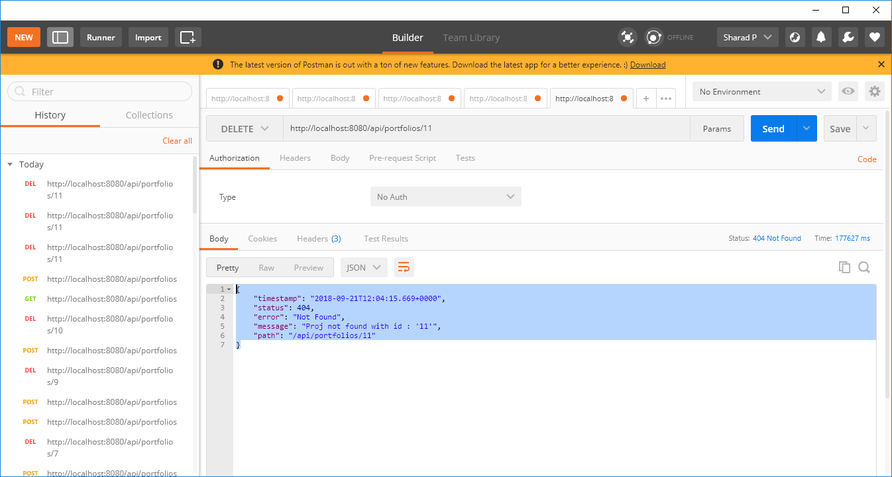

Response:

|  |
| --- |
| {  "timestamp": "2018-09-21T12:04:15.669+0000",  "status": 404,  "error": "Not Found",  "message": "Proj not found with id : '11'",  "path": "/api/portfolios/11"  } |

Coverage Report:

